1. Query Select table employee

Select employeeNumber, firstName,lastName, jobTitle form employees;

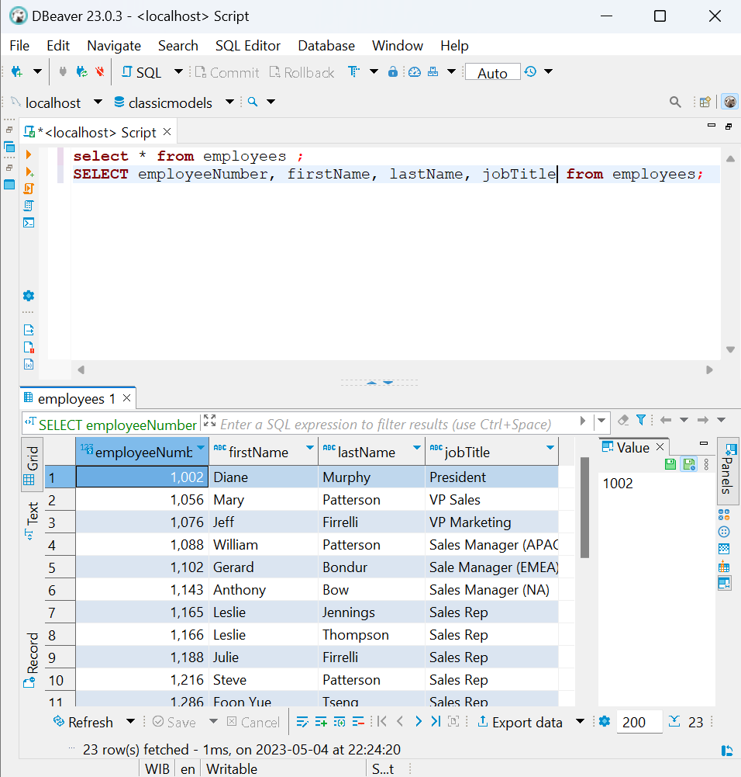

1. Query Update Data

Update employee set jobTitle=’RAJA sales’ where employeeNumber=1002;

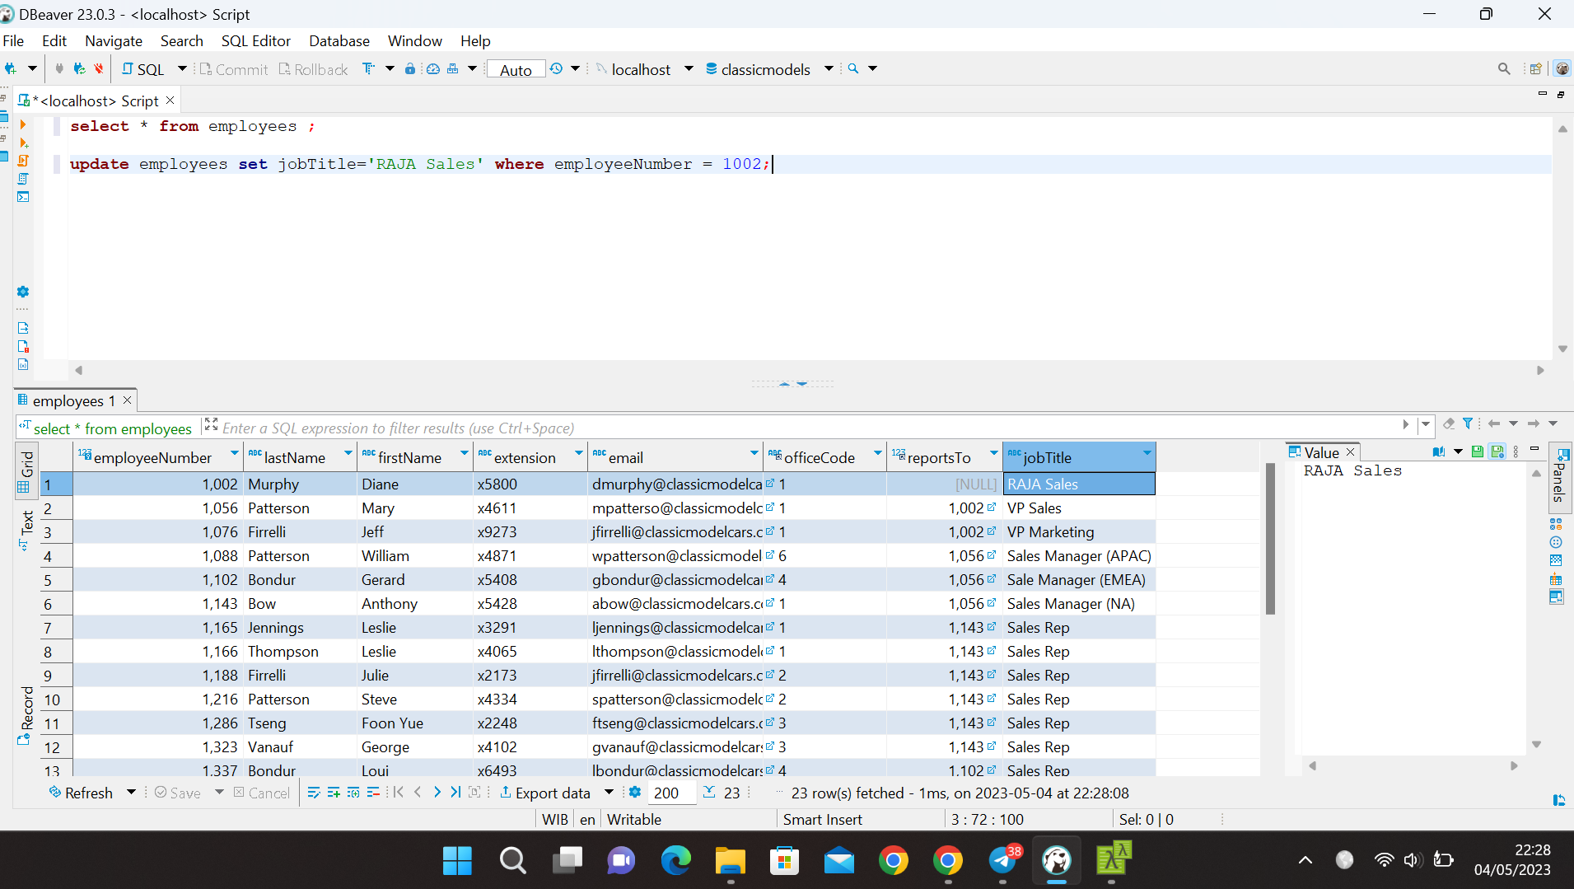

1. Query Count Data

Select jobTitle, count(\*) from employee group by jobTitle;

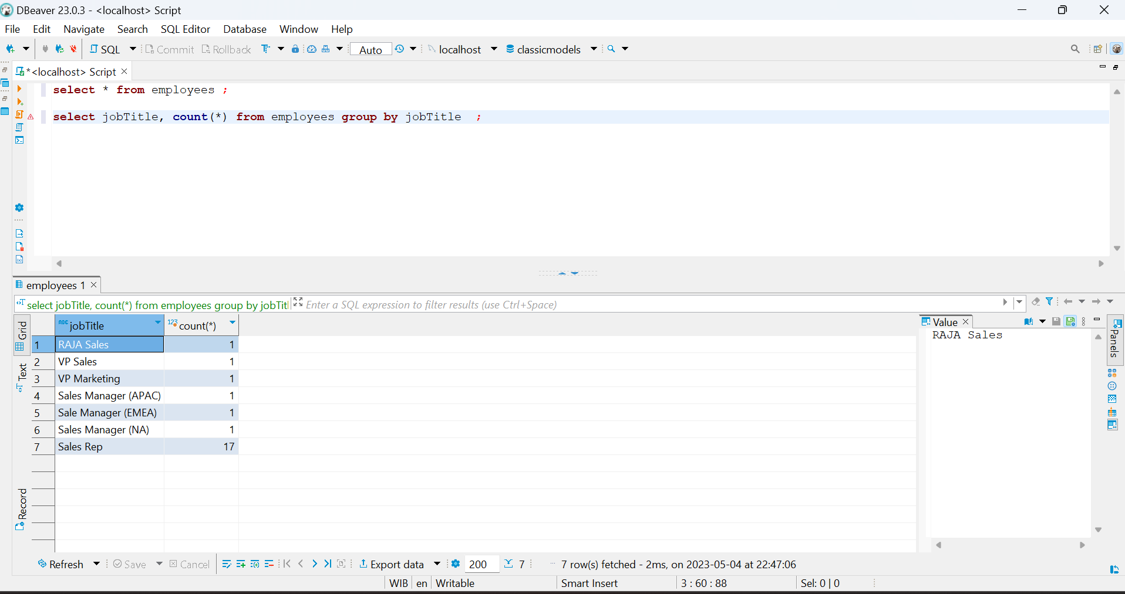

1. Query Inner Join Data

Select   
 productCode,  
 productName,  
 textDescription  
from  
 products t1  
inner join productlines t2  
 on t1.productline = t2.producline;

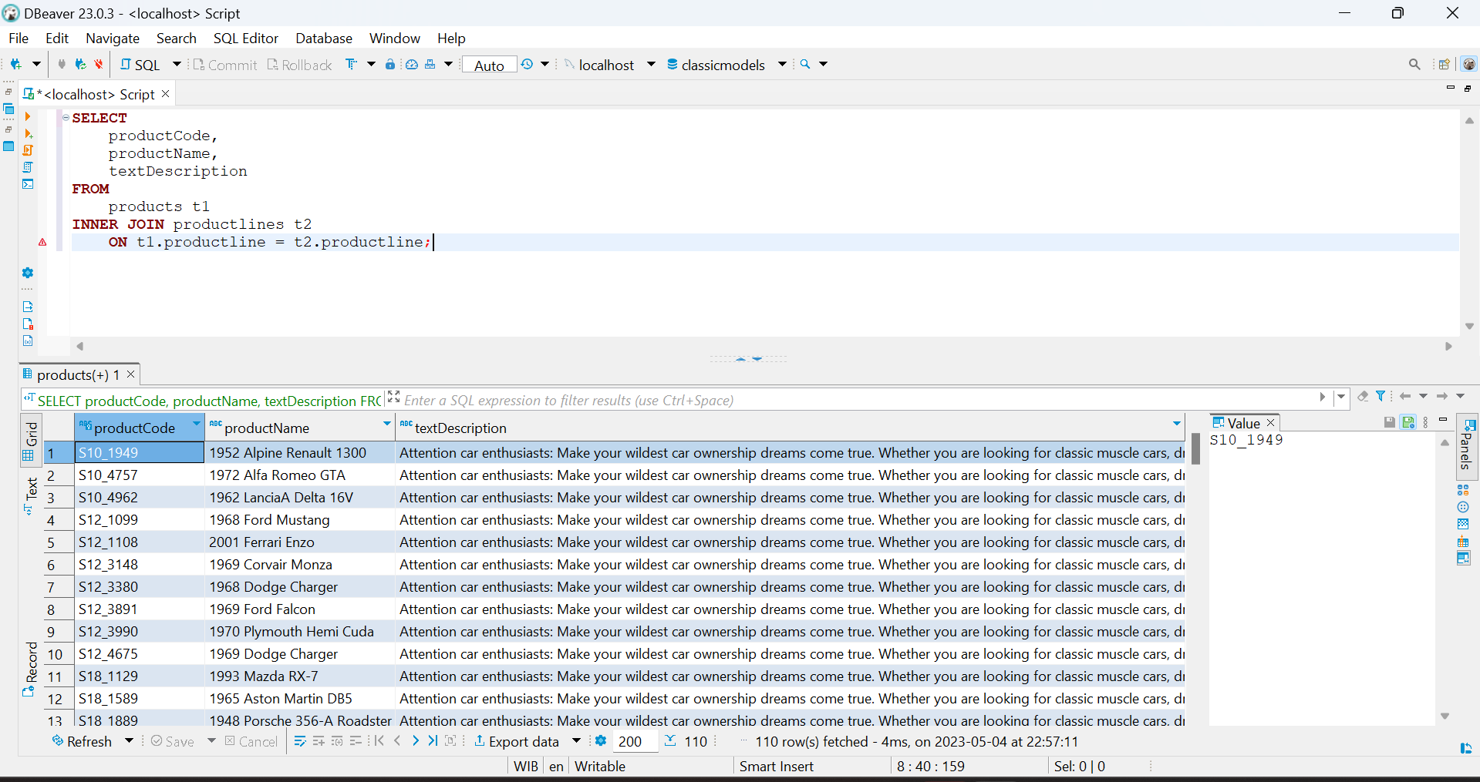

1. Query Select Data LIKE

SELECT

employeeNumber,

lastName,

firstName

FROM

employees

WHERE

firstName LIKE 'a%';

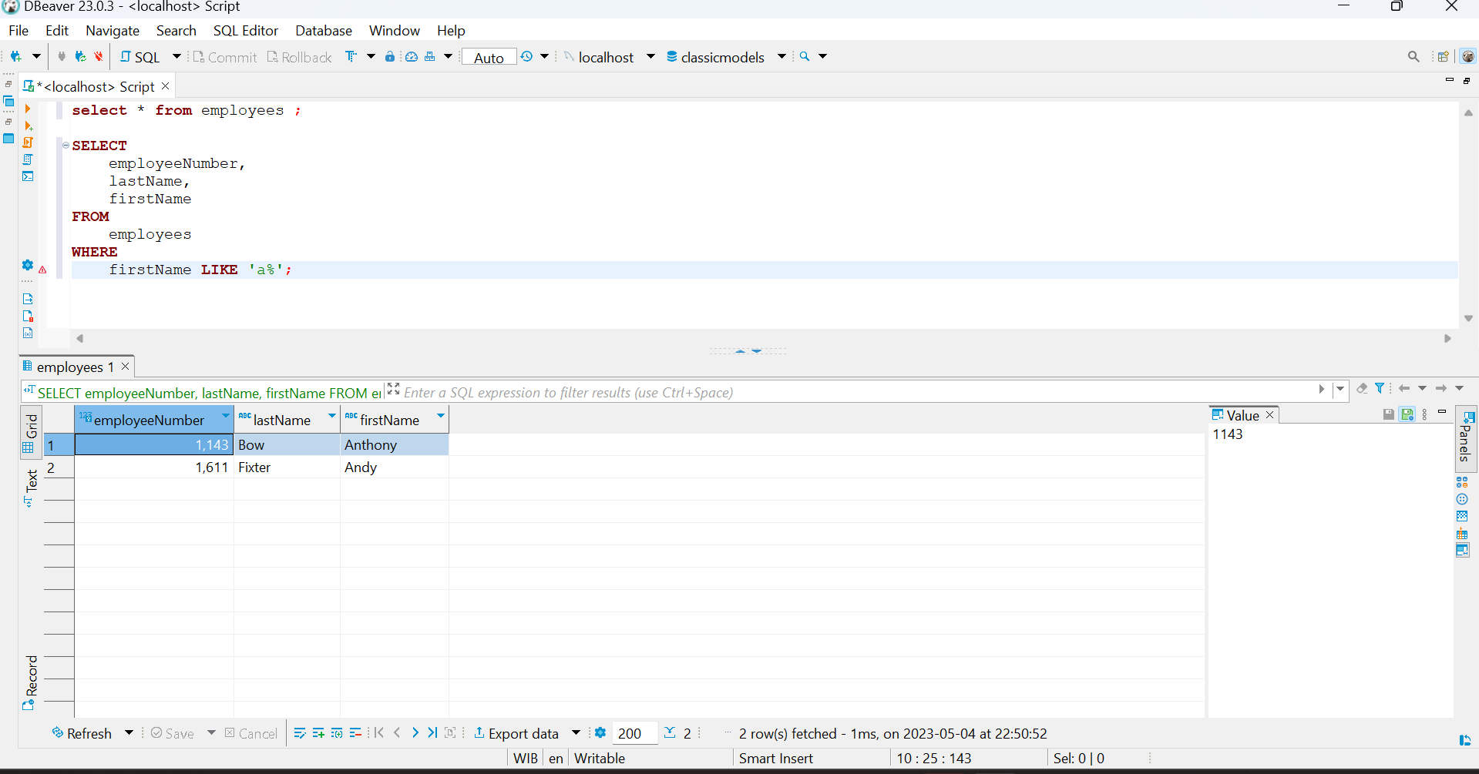

1. Query Data Subquery

SELECT

customerNumber,

checkNumber,

amount

FROM

payments

WHERE

amount = (SELECT MAX(amount) FROM payments);

